GI Bill Comparison Tool Product Outline

Overview

Product

GI Bill Comparison Tool

* *Initiatives: institution ratings system*

We have built a ratings system for the GI Bill Comparison tool to allow veterans and their families to evaluate educational institutions.

Outcome Summary

Improve the visual display of institution reviews to appear more pleasant. The current designs *in staging* contain unnecessary visual components. The proposed designs

*Where does this come from?*

Calculations based off data from survey results submitted by veteran graduates.

Problem

What is the problem and who is affected?

The current institution ratings are in staging. For veterans and their families to better compare, evaluate, and apply to a university, it is crucial to provide a rating system that is simple to navigate and view.

Discovery

What are we building?

*Key features*

* Replaced star components under the subcategories with progress bars

Assumptions

*Initiatives*

Before – current design (in staging)

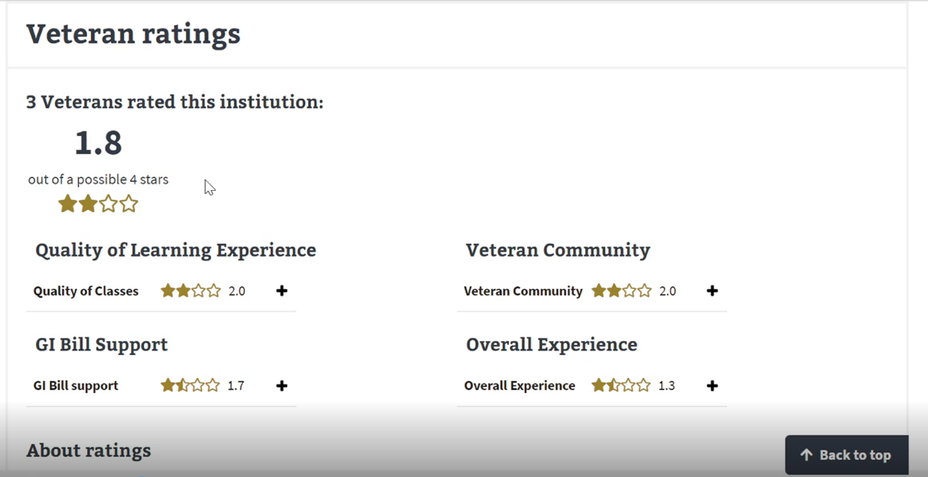Before continued – design in staging

After – design proposal (desktop)

[*Click to view Sketch file*](https://www.sketch.com/s/7504adeb-d610-4dd9-a316-36e8b4445a28)



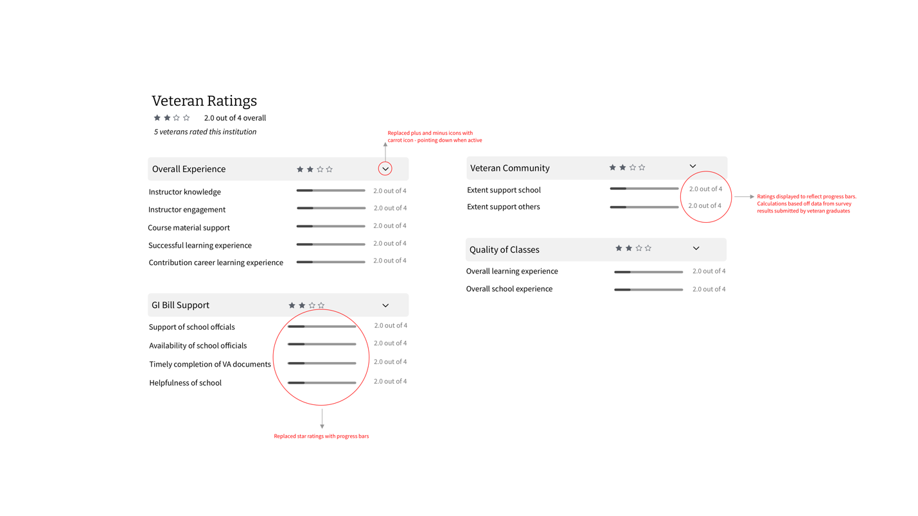

After – design proposal continued (mobile)

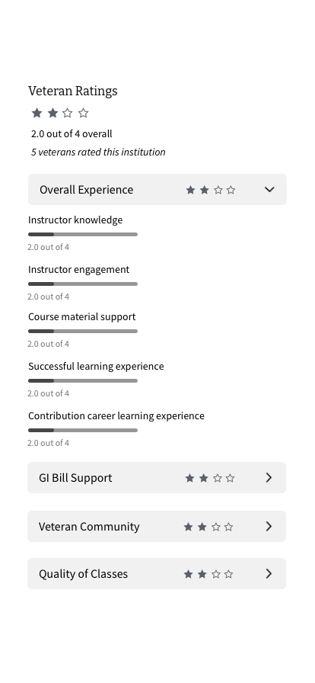

After – design proposal continued (mobile)



